FINAL EXAMINATION

OS 45O

BY: CHUA FRANCIS EDWARD

Green Technology

The term “technology” refers to the application of knowledge for practical purposes.
The field of “green technology” encompasses a continuously evolving group of methods and materials, from techniques for generating energy to non-toxic cleaning products.
The present expectation is that this field will bring innovation and changes in daily life of similar magnitude to the “information technology” explosion over the last two decades. In these early stages, it is impossible to predict what “green technology” may eventually encompass.

The goals that inform developments in this rapidly growing
field include:
Sustainability - meeting the needs of society in ways that can continue indefinitely into the future without damaging or depleting natural resources. In short, meeting present needs without compromising the ability of future generations to meet their own needs.
“Cradle to cradle” design - ending the “cradle to grave” cycle of manufactured products, by creating products that can be fully reclaimed or re-used.
Source reduction - reducing waste and pollution by changing patterns of production and consumption.
Innovation - developing alternatives to technologies - whether fossil fuel or chemical intensive agriculture - that have been demonstrated to damage health and the environment.
Viability - creating a center of economic activity around technologies and products that benefit the environment, speeding their implementation and creating new careers that truly protect the planet.
Examples of green technology subject areas
Energy
Perhaps the most urgent issue for green technology, this includes the development of alternative fuels, new means of generating energy and energy efficiency.
Green building
Green building encompasses everything from the choice of building materials to where a building is located.
Environmentally preferred purchasing
This government innovation involves the search for products whose contents and methods of production have the smallest possible impact on the environment, and mandates that these be the preferred products for government purchasing.
Green chemistry
The invention, design and application of chemical products and processes to reduce or to eliminate the use and generation of hazardous substances.
Green nanotechnology
Nanotechnology involves the manipulation of materials at the scale of the nanometer, one billionth of a meter. Some scientists believe that mastery of this subject is forthcoming that will transform the way that everything in the world is manufactured. “Green nanotechnology” is the application of green chemistry and green engineering principles to this field.

Top Ten U.S. Cities with Most Green Technologies

1) Los Angeles, CA
2) San Francisco, CA
3) Houston, TX
4) Washington DC.
5) Dallas-Fort Worth, TX
6) Chicago, IL
7) Denver, CO
8) Minneapolis-St. Paul, MN
9) Atlanta, GA
10) Seattle, WA

Green technology was hot in 2008. Barack Obama won the presidential election promising green jobs to Rust Belt workers. Investors poured $5 billion into the sector just through the first nine months of the year. And even Texas oilmen like T. Boone Pickens started pushing alternative energy as a replacement for fossil fuels like petroleum, coal and natural gas.
But there's trouble on the horizon. The economy is hovering somewhere between catatonic and hebephrenic, and funding for the big plans that green tech companies laid in 2008 might be a lot harder to come by in 2009. Recessions haven't always been the best times for environmentally friendly technologies as consumers and corporations cut discretionary spending on ethical premiums.
Still, green technology and its attendant infrastructure are probably the best bet to drag the American economy out of the doldrums. So, with the optimism endemic to the Silicon Valley region, we present you with the Top 10 Green Tech Breakthroughs of 2008, alternatively titled, The Great Green Hope.
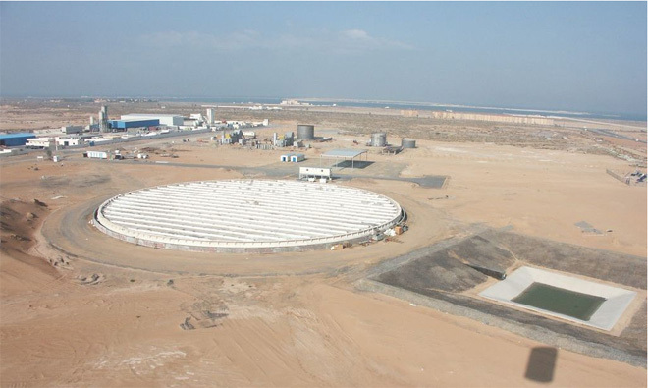
10. THE ISLAND OF THE SOLAR
With money flowing like milk and honey in the land of solar technology, all sorts of schemers and dreamers came streaming into the area. One Swiss researcher, Thomas Hinderling, wants to build solar islands several miles across that he claims can produce hundreds of megawatts of relatively inexpensive power. Though most clean tech advocates question the workability of the scheme, earlier this year, Hinderling's company Centre Suisse d'Electronique et de Microtechnique received $5 million from the Ras al Khaimah emirate of the United Arab Emirates to start construction on a prototype facility, shown above, in that country. (Image: Centre Suisse d'Electronique et de Microtechnique)
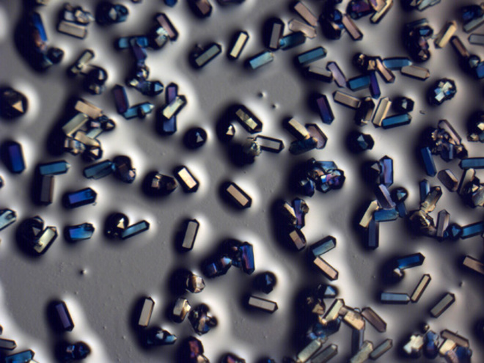
9. NEW MATERIALS CAGE CARBON
Carbon capture and sequestration has a seductively simple appeal: We generate carbon dioxide emissions by burning geology — coal and oil — so to fix the problem, we should simply capture it and inject it back into the ground.
It turns out, however, that it's not quite so simple. Aside from finding the right kind of empty spaces in the earth's crust and the risks that the CO2 might leak, the biggest problem with the scheme is finding a material that could selectively snatch the molecule out of the hot mess of gases going up the flues of fossil fuel plants.
That's where two classes of special cage-like molecules come into play, ZIFs and amines. This year, Omar Yaghi, a chemist at UCLA, announced a slough of new CO2-capturing ZIFs and Chris Jones, a chemical engineer at Georgia Tech, reported that he'd made a new amine that seems particularly well-suited to working under real-world condition. Both materials could eventually make capturing CO2 easier -- and therefore, more cost effective.
Perhaps better still, Yaghi's lab's technique also defined a new process for quickly creating new ZIFs with the properties that scientists — and coal-plant operators — want. Some of their crystals are shown in the image above. (Image: Omar Yaghi and Rahul Banerjee/UCLA)
8. GREEN TECH LEGISLATION GETS REAL
On the federal and state levels, several historic actions put the teeth into green tech bills passed over the last few years. A review committee of the EPA effectively froze coal plant construction, a boon to alternative energy (though earlier this month the EPA ignored the committee's ruling and it is unclear how the issue will be settled). In California, the state unveiled and approved its plan to regulate carbon dioxide emissions, which could be a model for a nationwide system. Combined with the green-energy tax credits in the $700-billion bailout bill, the government did more for green tech in 2008 than in whole decades in the past.
7. THE CATALYST THAT COULD ENABLE SOLAR
In July, MIT chemist Daniel Nocera announced that he'd created a catalyst that could drop the cost of extracting the hydrogen and oxygen from water.
Combined with cheap photovoltaic solar panels (like Nanosolar's), the system could lead to inexpensive, simple systems that use water to store the energy from sunlight. In the process, the scientists may have cleared the major roadblock on the long road to fossil fuel independence: Reducing the on-again, off-again nature of many renewable power sources.
"You've made your house into a fuel station," Daniel Nocera, a chemistry professor at MIT told Wired.com. "I've gotten rid of all the goddamn grids."
The catalyst enables the electrolysis system to function efficiently at room temperature and at ordinary pressure. Like a reverse fuel cell, it splits water into oxygen and hydrogen. By recombining the molecules with a standard fuel cell, the O2 and H2 could then be used to generate energy on demand.
6. PICKENS PLAN PUSHES POWER PLAYS INTO AMERICAN MAINSTREAM
Texas oilman T. Boone Pickens might be a lot of things, but environmentalist he is not. That's why his support for a nationwide network of wind farms generated so much excitement. While his solution for transportation, natural gas vehicles, may not pan out, his Pickens Plan is the most visible alternative energy plan out there and it began to channel support from outside coastal cities for finding new sources of energy.
Of course, no one said Pickens is stupid. If his plan was adopted and major investments in transmission infrastructure were made, his wind energy investments would stand to benefit.
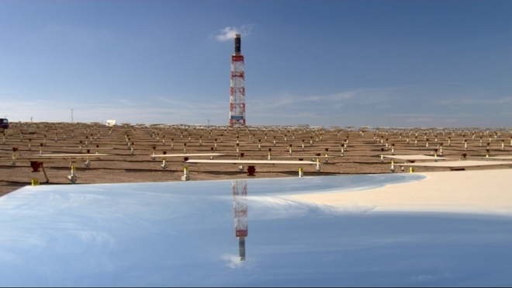
5. SOLAR THERMAL PLANTS RETURN TO THE DESERTS
When most people think of harnessing the sun's power, they imagine a solar photovoltatic panel, which directly converts light from the sun into electricity. But an older technology emerged as a leading city-scale power technology in 2008: solar thermal. Companies like Ausra, BrightSource, eSolar, Solel, and a host of others are using sunlight-reflecting mirrors to turn liquids into steam, which can drive a turbine in the same way that coal-fired power plants make electricity.
Two companies, BrightSource and Ausra, debuted their pilot plants. They mark the first serious solar thermal experimentation in the United States since the 1980s. BrightSource's Israeli demo plant is shown above. (Image: BrightSource)
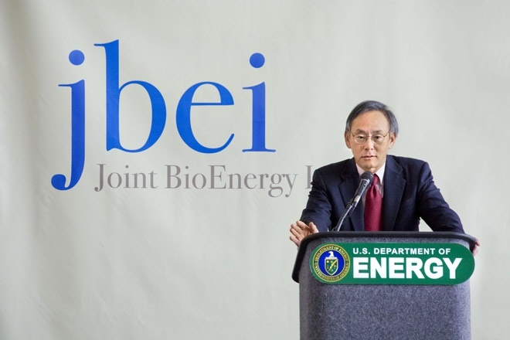
4. OBAMA PICKS A GREEN TECH EXPERT TO HEAD DOE
President-elect Barack Obama ran on the promise of green jobs and an economic stimulus package that would provide support for scientific innovation. Then, Obama picked Steven Chu, a Nobel-prize winning physicist, to head the Department of Energy. Chu had been focused on turning Lawrence Berkeley National Laboratory into an alternative-energy powerhouse. The green tech community rejoiced that one of their own would be in the White House.
That's because green tech is going to need some help. With the world economy falling into recession, the price of oil has dropped, even though there are serious concerns about the long-term oil supply. When energy prices drop, clean tech investments don't seem quite as attractive, and the renascent industry could be in trouble. It's happened before, after all.
Back in the '70s, geopolitical events sent the price of oil soaring, which, as it tends to, created a boom in green tech. But the early 1980s saw the worst recession since the Depression. Sound familiar? In the poor economic climate, focus and funds were shifted away from green tech. The last nail in the coffin was the election of Ronald Reagan, who immediately pulled off the solar panels Jimmy Carter had placed on the White House. The green tech industry collapsed.
History has given U.S. alternative energy research a second chance and environmental advocates hope that a different president will lead to a very different result. (Image: DOE)
3. SOLAR CELL PRODUCTION GETS BIG, GIGA(WATT)BIG
Every clean tech advocate's dream is a power-generating technology that could compete head-to-head with coal, the cheapest fossil fuel, on price alone. Nanosolar, one of a new generation of companies building solar panels out of cheap plastics, could be the first company to get there. Early this year, the company officially opened its one-gigawatt production facility, which is many times the size of most previous solar facilities.
Nanosolar, in other words, has found a process that can scale: it works as well in production as it does in the lab. That's the main reason that the company has picked up half-a-billion dollars in funding from investors like MDV's Erik Straser.
"[It's the] first time in industry a single tool with a 1GW throughput," Straser wrote in an e-mail. "It's a key part of how the company is achieving grid parity with coal."

2. PROJECT BETTER PLACE FINDS HOMES
Green technologies are dime a dozen, but a business model that could allow an entirely new, green infrastructure to be built is a rare thing.
Doing just that is the centerpiece of SAP veteran Shai Agassi's vision for Project Better Place, a scheme that would distribute charging and swappable battery stations throughout smallish geographies like Israel, Hawaii and San Francisco. So far, there's very little steel in the ground, but in early December, the company's first charging location opened in Tel Aviv, Israel. Agassi's plan is one of several projects — like new biofuels rail terminals — that could create fundamentally new energy ecosystems.
Some of these systems, however, are actually throwbacks to earlier eras. As Peter Shulman, a historian of technology at Case Western Reserve University, likes to remind his students: in the early 20th century, before the Model T, one-third of all cars were electric. (Image: Joe Puglies/WIRED)
1. CALERA'S GREEN CEMENT DEMO PLANT OPENS
Cement? With all the whiz bang technologies in green technology, cement seems like an odd pick for our top clean technology of the year. But here's the reason: making cement — and many other materials — takes a lot of heat and that heat comes from fossil fuels.
Calera's technology, like that of many green chemistry companies, works more like Jell-O setting. By employing catalysis instead of heat, it reduces the energy cost per ton of cement. And in this process, CO2 is an input, not an output. So, instead of producing a ton of carbon dioxide per ton of cement made — as is the case with old-school Portland cement — half a ton of carbon dioxide can be sequestered.
With more than 2.3 billion tons of cement produced each year, reversing the carbon-balance of the world's cement would be a solution that's the scale of the world's climate change problem.

What is Netbook
A netbook (a portmanteau of Internet and notebook) is a class of laptop computer designed for wireless communication and access to the Internet.^{[1]}
Primarily designed for web browsing and e-mailing, netbooks rely heavily on the Internet for remote access to web-based applications"^{[2]} and are targeted increasingly at cloud computing users who require a less powerful client computer.^{[3]} Netbooks typically run either Linux or Windows XP operating systems^{[2]} rather than more resource-intensive operating systems like Windows Vista.^{[4]} The devices range in size from below 5 inches^{[5]} to over 13,^{[6]} typically weigh 2 to 3 pounds (~1 kg) and are often significantly cheaper than general purpose laptops.^{[2]}

What is in vitro fertilization?

IVF involves stimulating multiple follicles and eggs to develop in the ovaries, taking eggs from the woman, fertilizing them in the laboratory with her partner's sperm and transferring the resulting embryos back to her uterus 2-6 (usually 3 or 5) days later.
The first IVF baby in the world (Louise Brown) was born in July of 1978 in England. Louise Brown was 28 when she delivered her own baby in 2006. Her baby was conceived without IVF. Hundreds of thousands of children are now born annually as a result of the IVF technique.

The babies' names, gender and birth weight in birth order are:
^{[2][3][4]}
- Noah Angel Solomon - male; 2 lbs 8 oz
- Maliyah Angel Solomon - female; 2 lbs 2 oz
- Isaiah Angel Solomon - male; 3 lbs 1 oz
- Nariyah Angel Solomon - female; 2 lbs 3 oz
- Makai Angel Solomon - male; 1 lbs 12 oz
- Josiah Angel Solomon - male; 2 lbs 9 oz
- Jeremiah Angel Solomon - male; 1 lb 13 oz
- Jonah Angel Solomon - male; 2 lbs 7 oz

What are the Agencies of DOST
Food and Nutrition Research Institute (FNRI)
Forest Products Research and Development Institute (FPRDI)
Advanced Science and Technology Institute (ASTI)
Philippine Atmospheric, Geophysical and Astronomical Services Administration (PAGASA)
Science Education Institute (SEI)
Philippine Institute of Volcanology and Seismology (PHIVOLCS)
Science and Technology Information Institute (STII)
Technology Application and Promotion Institute(TAPI)
Philippine Council for Advanced Science and Technology Research and Development (PCASTRD)
Philippine Council for Health Research and Development (PCHRD)
Philippine Council for Industry and Energy Research and Development (PCIERD)

Sectoral Planning Councils

 | - | Philippine Council for Aquatic Marine Research and Development (PCAMRD)
 | - | Philippine Council for Agriculture, Forestry and Natural Resources Research and Development (PCARRD)
 | - | Philippine Council for Advanced Science and Technology Research and Development (PCASTRD)
 | - | Philippine Council for Health Research and Development (PCHRD)
 | - | Philippine Council for Industry and Energy Research and Development (PCIERD)
Research and Development Institutes

 | - | Advanced Science and Technology Institute (ASTI)
 | - | Food and Nutrition Research Institute (FNRI)
 | - | Forest Products Research and Development Institute (FPRDI)
 | - | Industrial Technology Development Institute (ITDI)
 | - | Metals Industry Research and Development Center (MIRDC)
 | - | Philippine Nuclear Research Institute (PNRI)
 | - | Philippine Textile Research Institute (PTRI)
Service Institutes

 | - | Philippine Atmospheric, Geophysical and Astronomical Services Administration (PAGASA)
 | - | Philippine Institute of Volcanology and Seismology (PHIVOLCS)
 | - | Philippine Science High School (PSHS)
 | - | Science Education Institute (SEI)
 | - | Science and Technology Information Institute (STII)
 |  | Technology Application and Promotion Institute (TAPI)
Advisory Bodies

 | - | National Academy of Science and Technology (NAST)
 | - | National Research Council of the Philippines (NRCP)

Who is the Secretary of the Department of Science and Technology?

Estrella F. Alabastro

